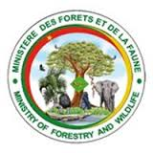
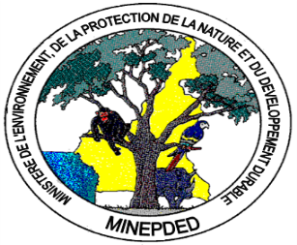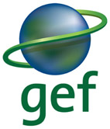
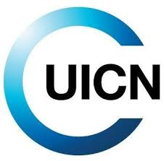
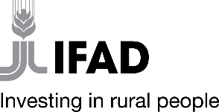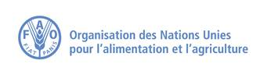

JOB DESCRIPTION
GEF Project GCP/CMR/904/GFF “Enabling Land Degradation Neutrality and mitigation of greenhouse gas emissions in Cameroon’s Sudano-Sahelian agro-ecological zone”

Position title: Gender specialist
Reports to: National Project Technical Coordinator, National Project Director (NPD) and FAO GEF focal Point, Cameroon office
Technical / Dotted Reporting Manager(s): FAO GEF Agency
Supervises: National Project Director (NPD)
Grade/Career Level:

Location: Yaoundé
- Mission of the Department:
The Sudano-Sahelian semi-arid agro-ecological zone, one of Cameroon’s five agro-ecological zones, covers the North and Far North Regions of the country, extending over a combined area of about 10 million hectares. The zone comprises both natural habitats and agroecosystems. The production landscapes play an important role in local livelihoods, primarily through the agriculture and livestock sector.
Land degradation is destabilizing the agro-ecological conditions of the Sudano-Sahelian zone. The region is the most fragile ecological zone in Cameroon, with nearly 5 million hectares of land highly degraded – a situation exacerbated by climate variability and change, including frequent prolonged droughts and erratic heavy rains.
Cameroon has made a commitment to achieve land degradation neutrality (LDN) by 2030, with LDN achieved in at least 90 percent of municipalities within priority areas to combat land degradation.
The GCP /CMR/904/GFF project aims “to enable land degradation neutrality (LDN) and mitigation of greenhouse gas emissions in the production landscapes of Cameroon’s Sudano-Sahelian agroecological zone”. The objective will be achieved through implementation of the following components in six (6) municipalities within two (2) target regions – North and Far North:
- Component 1: Improving the Sub-National Enabling Environment for LDN
- Component 2: Strengthening Initiatives in line with Municipal LDN Targets
- Component 3: Knowledge management and Monitoring & Evaluation.
The Global Environment Facility (GEF) Council approved this 5-years project which a PMU executed by the Ministry of Environment Protection of Nature and Sustainable Development (MINEPDED) with FAO as the GEF Agency.
For this project we are looking a passionate and ambitious Gender expert who will be responsible for providing technical gender input into project activities.

- Major Functions:
The Gender expert will provide technical support in project execution, particularly in the field of gender mainstreaming, gender analysis and gender sensitive programming and monitoring, including the execution of the baseline assessment study.

- Major Duties and Responsibilities:
He/she will carry out the following tasks:
- Provide capacity building and support to the project team and executing partners to ensure gender concerns are mainstreamed and Gender Action Plan is effectively implemented;
- Develop a gender diagnosis through the collection of primary and secondary data concerning gender issues in risk management, the identification and comprehensive assessment of the gender issue in the project (collection – analysis of information, ways to understand variations in resources, skills and challenges);
- Formulate objectives for reducing inequalities between women and men for the project;
- Put in place a mechanism for Monitoring – evaluation of the integration of the gender dimension in the project;
- Develop a manual to facilitate the integration of the gender dimension in the project;
- Support technical managers in the development of terms of reference, technical specifications taking into consideration gender;
- Review implementation of the GAP annually and update the plan at mid-term or earlier as necessary;
- Provide guidance and support to implement FPIC and ensure Indigenous Peoples are fully integrated in project approach and no negative impacts are perceived;
- Facilitate partner discussion in case of issues raised on ESS and ensure all project stakeholders have access and know the appropriate grievance channels.

- Profile:
Required Qualifications:
- Hold at least a university degree [GCA + 5 years] in Social Sciences (Sociology, Anthropology); or in Law; or in Economics, or any other equivalent field;
- Have at least one certified gender dimension training;
- Have a deep knowledge of gender issues in Cameroon in relation to issues of climate change and sustainable land management (will be an asset);
- Possess strong facilitation and communication skills, and excellent analytical and writing skills;
- Graduate degree in relevant field related to gender and indigenous peoples (IP) in natural resource management;
- At least five years of experience in relevant field related to gender, IP and natural resource management;
- At least three years of working with implementation of GEF/FAO/UN or other donor-funded projects;
- Previous experience working with local communities in Cameroon;
- Demonstrated commitment to gender and IP topics related to natural resource management and/or agriculture.

Required Skills and Competencies:
- The consultant should be an experienced gender equality and/or GBV specialist with at least 3 years of professional experience in international development. A post-graduate qualification in development, gender studies, social sciences or related disciplines is preferred. Demonstrated experience in gender-related research and analysis, preparation of high-quality reports, briefings and communications materials, and excellent written communication skills are required.
- Demonstrated understanding of gender inequality, harmful practices, and gender based violence. The ability to meet deadlines, work with a minimum of supervision, and deliver quality products is essential. Previous experience in knowledge management will be an asset. Excellent interpersonal skills and a commitment to the values and goals of the United Nations and UN Charter are also required. Experience in and/or knowledge of the UN system and/or UNFPA is desirable. Ability to travel is essential.
Other skills
- Demonstrate integrity by applying the values and ethical standards of the United Nations;
- Displays sensitivity and adaptability to culture, gender, religion, race, nationality, and age;
- Treats all people fairly without favoritism;
- Able to communicate effectively in writing to a wide variety of audiences in a simple and concise manner;
- Able to work in a high pressure environment with tight and frequent deadlines, managing numerous tasks simultaneously;
- Able to handle confidential and politically sensitive matters in a responsible and mature manner;
- Works well in a team;
- Projects a positive image and is willing to take on a wide range of tasks.

- Working Relationships:
Under the supervision of the NPTC, the Project Gender expert will work closely with MINEPDED and FAO. He will interacts with project partners (IFAD, IUCN, FEICOM, etc.) and other partner national governmental institutions, non-governmental organizations, academic institutions, the media, specialists/ consultants and other stakeholders.
This job description covers the main tasks and conveys the spirit of the sort of tasks that are anticipated proactively from staff. Other tasks may be assigned as necessary according to Project needs.

Date: Approved by:

