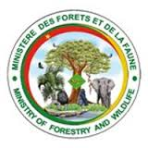
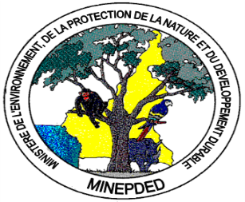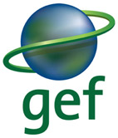
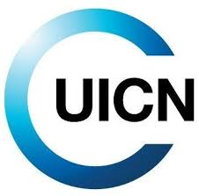
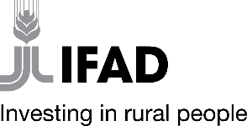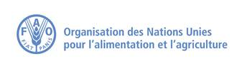

JOB DESCRIPTION
GEF Project GCP/CMR/904/GFF “Enabling Land Degradation Neutrality and mitigation of greenhouse gas emissions in Cameroon’s Sudano-Sahelian agro-ecological zone”

Position title: National Project Technical Coordinator (NPTC)
Reports to: National Project Director (NPD) and FAO GEF focal Point, Cameroon office
Technical / Dotted Reporting Manager(s): FAO GEF Agency
Supervises: Natural resource management, sustainable land management, communication, M&E and Knowledge Management specialist; Environmental and Social Safeguards Officer and Finance Manager
Grade/Career Level:

Location: Yaoundé
- Mission of the Department:
The Sudano-Sahelian semi-arid agro-ecological zone, one of Cameroon’s five agro-ecological zones, covers the North and Far North Regions of the country, extending over a combined area of about 10 million hectares. The zone comprises both natural habitats and agroecosystems. The production landscapes play an important role in local livelihoods, primarily through the agriculture and livestock sector.
Land degradation is destabilizing the agro-ecological conditions of the Sudano-Sahelian zone. The region is the most fragile ecological zone in Cameroon, with nearly 5 million hectares of land highly degraded – a situation exacerbated by climate variability and change, including frequent prolonged droughts and erratic heavy rains.
Cameroon has made a commitment to achieve land degradation neutrality (LDN) by 2030, with LDN achieved in at least 90 percent of municipalities within priority areas to combat land degradation.
The GCP /CMR/904/GFF project aims “to enable land degradation neutrality (LDN) and mitigation of greenhouse gas emissions in the production landscapes of Cameroon’s Sudano-Sahelian agroecological zone”. The objective will be achieved through implementation of the following components in six (6) municipalities within two (2) target regions – North and Far North:
- Component 1: Improving the Sub-National Enabling Environment for LDN
- Component 2: Strengthening Initiatives in line with Municipal LDN Targets
- Component 3: Knowledge management and Monitoring & Evaluation.
The Global Environment Facility (GEF) Council approved this 5-years project which a PMU executed by the Ministry of Environment Protection of Nature and Sustainable Development (MINEPDED) with FAO as the GEF Agency.
For this project, we are looking for a dynamic and committed National Project Technical Coordinator (NPTC) who will be responsible for providing substantial technical support to implementation of technical components and the day-to-day management of the project. He/she will be responsible for the overall planning, coordination of project activities, and monitoring of project results.

- Major Functions:
The National Project Technical Coordinator (NPTC) will be in charge of daily implementation, management, administration, and technical supervision of the project.

- Major Duties and Responsibilities:
He/she will carry out the following tasks:
- Coordinate and closely monitor the planning, implementation and monitoring of the project as a whole, providing relevant grassroots initiatives;
- Coordinate, closely supervise and facilitate the work of PMU staff at the national level and in each intervention region, as well as short-term national and international project consultants;
- Ensure a high level of collaboration between the various stakeholders (governments, technical and financial partners, civil society organizations, local communities, indigenous peoples, research institutions, private actors) at the local, regional and national levels;
- Provide technical support and inputs to project executing partners and experts, and ensure that best practices, tools and methodologies drawn from relevant initiatives and knowledge partners are well integrated into implementation of the technical components;
- Lead technical discussions and planning and deliver specific technical trainings to partners;
- ensure a high level of collaboration among participating institutions and organizations at the national, regional and municipal levels;
- coordinate and monitor closely the implementation of project activities, and provide close supervision to the field (regional) coordinator;
- track the project’s progress and ensure timely delivery of inputs and outputs;
- providing technical support and review outputs delivered by partners;
- implement and manage the project’s monitoring and communications plans;
- organize project workshops and meetings to monitor progress and prepare Annual Budgets and Work Plans;
- submitting the six-monthly Project Progress Reports (PPRs) to the PSC and FAO;
- preparing the first draft of the Project Implementation Review (PIR);
- Ensure compliance with all provisions of the operational partnership agreements during implementation, including the delivery of reports by the due date, the achievement of all project outputs related to the three components and ensure the quality of the deliverables of the consultants nationals recruited;
- facilitate the information exchange between the project and FAO;
- inform the PSC and FAO of any delays and difficulties as they arise during implementation to ensure timely corrective measure and support.
- Perform other related duties as required.
- Profile:
Required Qualifications:

- Advanced degree in natural resource management, sustainable land management, or other relevant specialization.
- A minimum of 7 years of experience in the management of UN agencies’ environment projects.
- A minimum of 10 years of relevant professional experience, including practical experience in the implementation of interventions for the sustainable management of natural resources, institutional networking and decision- making advice.
- Proficiency in Excel, Word, PowerPoint, MS Office.

Required Skills and Competencies:
- Proven leadership and team management skills;
- Fluency in English and French;
- Skilled in negotiation, liaison and in relationship and conflict management;
- Strong skills in project planning, proposal writing, financing, management, implementation, and evaluation, and experience working with donors;
- Strong organizational and analytical skills;
- Strong vocational interest in land degradation;
- A working knowledge of financial management, especially of projects;
- Excellent inter-personal skills, with the ability to network and to develop and maintain strong relationships at all levels, both internally and with local communities, government agencies, the not-for-profit sector, the scientific community, the business community and the UN Network.
Other skills
- Demonstrate integrity by applying the values and ethical standards of the United Nations;
- Displays sensitivity and adaptability to culture, gender, religion, race, nationality, and age;
- Treats all people fairly without favoritism;
- Able to communicate effectively in writing to a wide variety of audiences in a simple and concise manner;
- Able to work in a high pressure environment with tight and frequent deadlines, managing numerous tasks simultaneously;
- Able to handle confidential and politically sensitive matters in a responsible and mature manner;
- Works well in a team;
- Projects a positive image and is willing to take on a wide range of tasks.

- Working Relationships:
The National Project Technical Coordinator (NPTC) will work closely with FAO (LTO and Cameroon GEF Focal Point). He will also work closely with the National Director from MINEPDED, and Technical advisers from MINEPDED and MINFOF. He will interacts with project partners (IFAD, IUCN, FEICOM, etc.) and other partner national governmental institutions, non-governmental organizations, academic institutions, the media, specialists/ consultants and other stakeholders.

This job description covers the main tasks and conveys the spirit of the sort of tasks that are anticipated proactively from staff. Other tasks may be assigned as necessary according to Project needs.

Date: Approved by:

